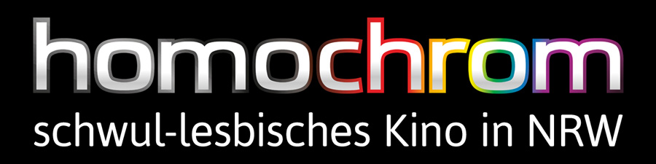

Short portrait:
homochrom stands for selected LGBT cinema in the metropolitan area Rhine-Ruhr, Europe's largest polycentric metropolitan area.

homochrom is the only institution in this area to organize LGBT screenings regularly—continuously since 2009. It comprises a monthly gay cinema series in six cities (Bochum, Cologne, Dortmund, Düsseldorf, Essen and Oberhausen), a bi-monthly lesbian screenings in four of these (all of them among the 10 biggest German cities) and since 2011 an annual queer premiere film festival in Cologne and Dortmund.

Programme:
The two monthly cinema series show recent fiction and documentary features, mostly as North Rhine-Westphalian premieres or previews, as well as queer classics. Although Germany is a dubbing country, many films are shown in the original with subtitles.

Filmfest homochrom is the youngest LGBT film festival in Germany, but also the only one in the huge metropolitan conurbation Rhine-Ruhr with the gay capital Cologne and the Westphalian beer-brewing and football centre Dortmund. From its first year on, Filmfest homochrom established itself with an exceptional programme of many German and European premieres, international filmmakers as guests, the audience awards "Chromie" and German subtitling (almost) throughout—the homochrom team translate many subtitles for premieres.

History:
homochrom was founded in 2009 by linguist and film scholar Martin Wolkner and graphic designer Michael de Sousa as a monthly gay film programme in Dortmund. It soon developed into a series, which now art-house cinemas in Bochum, Dortmund, Düsseldorf, Essen, Cologne and Oberhausen take part in. Since 2011 the newly founded non-profit association homochrom e.V. organizes the only LGBT film festival of the metropolitan area Rhine-Ruhr, in Cologne and Dortmund. Since July 2012 the bi-monthly lesbian film series finally complements the regular events in Cologne, Dortmund, Düsseldorf and Essen. Bisexual and transgender films are also cover in both series and the festival. In addition, homochrom organizes special screenings at the regional Gay Prides and other events.

Motivation:
LGBT or queer film programmes are very rare in North Rhine-Westphalia and Germany. With the exception of a few high-profile films (e.g. "Brokeback Mountain" or Almodóvar movies), even today cinemas usually don't show queer films, partly out of commercial, partly out of image concerns. That's why homochrom makes LGBT life visible in the biggest cities of NRW – is the only institution in this area to exclusively support queer motion picture art.

In doing so, homochrom's programme does not only serve cultural purposes, but also acknowledges its obligation to educate and promote tolerance. homochrom collaborates with Aids support groups and advisory centres, organizes discussions after screenings or invites filmmakers and actors to its screenings.

Programme:
The gay and lesbian cinema series show selected feature films or occasionally important documentary films, often as NRW premieres or previews, as well as classics of gay cinema. Although Germany is a dubbing country, many films are shown in the original version with German subtitles.
Filmfest homochrom is the youngest LGBT film festival in Germany, but it is also the only one in the Rhine-Ruhr area. The festival takes place in Germany's gay capital Cologne and in Dortmund, Westphalia's largest city. Although still in its beginning, it has already established itself with an exceptional progamme full of German or European premieres, international guests, the audience awards "Chromie" and German subtitling throughout—the festival team often does the translations for the premieres.

In 2011 not only two American directors attended the festival, but also the two Indian actors of the German premiere "Dunno Y … Na Jaane Kyun" with Bollywood's first gay kiss, which movie magazine Trailer/Choices called "simply a sensation". A Syrian-British actress also attended the Geman premiere of her movie "Three Veils". The Spanish film "For 80 Days – 80 Egunean" prevailed over the HIV doc "We Were Here" at the audience award that year.

In 2012 homochrom brought US comedy star Margaret Cho to Cologne for her first-ever professional appearance in Germany when premiering "Cho Dependent". This was reason enough for her to return in 2013 for her first German live shows. Actors Joe Conti (USA) and Klaus Nierhoff (D) also attended the festival. The audience favoured Glenn Close' costume drama "Albert Nobbs" over premieres such as the Turkish drama "Zenne Dancer", the beautiful Thai film "It Gets Better", the disability drama "Morgan" or Kathleen Turner's church-critical comedy "The Perfect Family".

In 2013 the festival was extended by a few days, took place under the patronage of Mrs. Hannelore Kraft, Minister-President of the state North Rhine-Westphalia, and was supported by the film fund Film und Medienstiftung NRW, the cultural office of Dortmund and other institutions. It was opened by the German premiere of "Kill Your Darlings" (starring Daniel Radcliffe). Attending guests were transsexual stand-up comedian Ian Harvie (USA), as well as the directors Anna Margarita Albelo (USA), Charlie Vaughn (USA) and Jens Roth (D). In the end, Albelo's dramedy "Who's Afraid of Vagina Wolf?" shaded the win of Oscar-nominated activist doc "How to Survive a Plague".

In 2014 the festival grew even bigger and diversified, spanning 5 days of programme in each city with 45 films. The opening film was the German premiere of HBO's AIDS drama "The Normal Heart" (with Julia Roberts, Mark Ruffalo, Alfred Molina etc.) and attendences rose to 2.400. The feature "Chromie" was awarded tot he transsexual romantic dramedy "Boy Meets Girl".

Association:
homochrom e.V. was founded and registered in Cologne in 2011 as a non-profit organization in order to support LGBT film art and culture through screenings. The board members commit to making the annual Filmfest homochrom a supra-regionally distinguished meeting point of LGBT film culture by establishing an emotionally appealing, artistically high-class, socio-culturally important programme, which promotes tolerance.

Board members are:
Martin Wolkner, founder of homochrom, linguist and film scholar;
Michael de Sousa, co-founder and graphic designer;
Sarah Horn, media scholar at Ruhr-University Bochum;
Philipp Stendebach, line producer at augenschein Filmproduktion.

homochrom e.V. is member of Kinoaktiv e.V., an affiliation of film initiatives in Cologne, and part of the QueerScope festivals in Germany.

Contact:
homochrom e.V. Martin Wolkner
P.O. Box 270 486 Phone: +49-163-8575061
50510 Cologne E-Mail: info@homochrom.de
Germany

